Experiment 1: Estimation of Fe²⁺ by Potentiometric Titration

Name: Vidhi P Shah
Registration No.: 21BCE1297
Slot: L11-L12
Date: 21/09/21

OBSERVATIONS:
Rough Titration:
Strength of standard potassium dichromate = 0.05N
Volume of FAS solution = 20mL

S. No | Volume of K₂Cr₂O₇ (mL) | EMF (Volt)
1 | 0.0000 | 0.4110
2 | 1.0000 | 0.4130
3 | 2.0000 | 0.4160
4 | 3.0000 | 0.4370
5 | 4.0000 | 0.5710
6 | 5.0000 | 0.5920
7 | 6.0000 | 0.6030
8 | 7.0000 | 0.6160
9 | 8.0000 | 0.6190
10 | 9.0000 | 0.6220
11 | 10.0000 | 0.6240

Fair Titration:
Strength of standard potassium dichromate = 0.05N
Volume of FAS solution = 20mL

S. No | Volume of K₂Cr₂O₇ (mL) | EMF(Volt) | ∆E (Volt) | ΔV (mL) | ΔE/ΔV (Volt/mL) | Average Volume (mL)
1 | 0.0000 | 0.4110
2 | 1.0000 | 0.4130 | 0.0020 | 1.0000 | 0.0020 | 0.5000
3 | 2.0000 | 0.4160 | 0.0030 | 1.0000 | 0.0030 | 1.5000
4 | 2.2000 | 0.4180 | 0.0020 | 0.2000 | 0.0100 | 2.1000
5 | 2.4000 | 0.4230 | 0.0050 | 0.2000 | 0.0250 | 2.3000
6 | 2.6000 | 0.4280 | 0.0050 | 0.2000 | 0.0250 | 2.5000
7 | 2.8000 | 0.4330 | 0.0050 | 0.2000 | 0.0250 | 2.7000
8 | 3.0000 | 0.4370 | 0.0040 | 0.2000 | 0.0200 | 2.9000
9 | 3.2000 | 0.4480 | 0.0110 | 0.2000 | 0.0550 | 3.1000
10 | 3.4000 | 0.4680 | 0.0200 | 0.2000 | 0.1000 | 3.3000
11 | 3.6000 | 0.4960 | 0.0280 | 0.2000 | 0.1400 | 3.5000
12 | 3.8000 | 0.5370 | 0.0410 | 0.2000 | 0.2050 | 3.7000
13 | 4.0000 | 0.5710 | 0.0340 | 0.2000 | 0.1700 | 3.9000
14 | 5.0000 | 0.5920 | 0.0210 | 1.0000 | 0.0210 | 4.5000
15 | 6.0000 | 0.6030 | 0.0110 | 1.0000 | 0.0110 | 5.5000

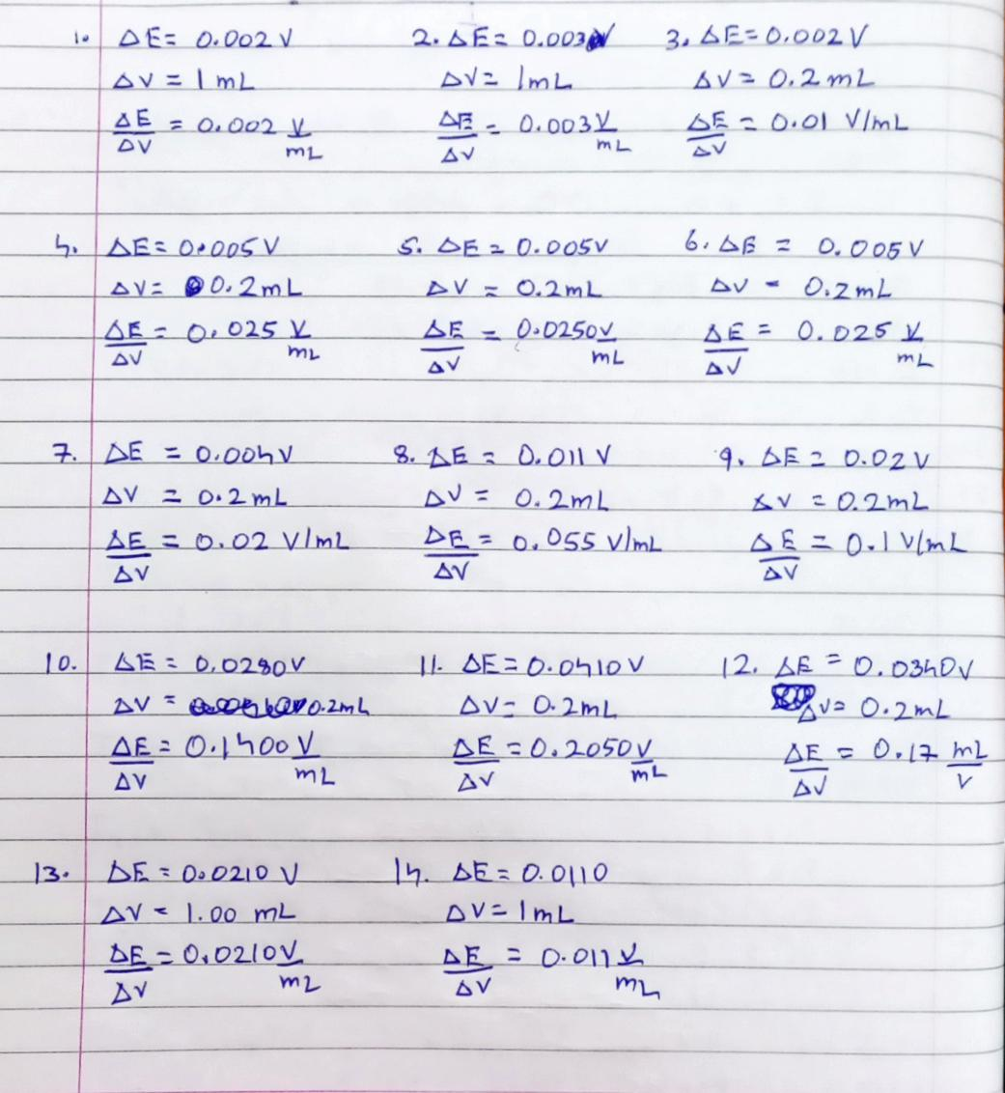

CALCULATIONS:

Volume of K₂Cr₂O₇ (from derivative graph) (V₁) = 3.7 mL
Normality of K₂Cr₂O₇ (N₁) = 0.05 N
Volume of Fe²⁺ solution (V₂) = 20 mL
Normality of Fe²⁺ solution (N₂) = ?
N₁ V₁ = N₂ V₂
N₂ = (N₁ V₁)/(V₂)
= 0.00925 N
Amount of Fe²⁺ present in 1 liter of the given solution = Eq. wt. (55.85) x Normality
= 0.5166125 g
Amount of Fe²⁺ present in whole given solution = [Eq. wt. (55.85) x Normality] / 10
= 0.05166125 g
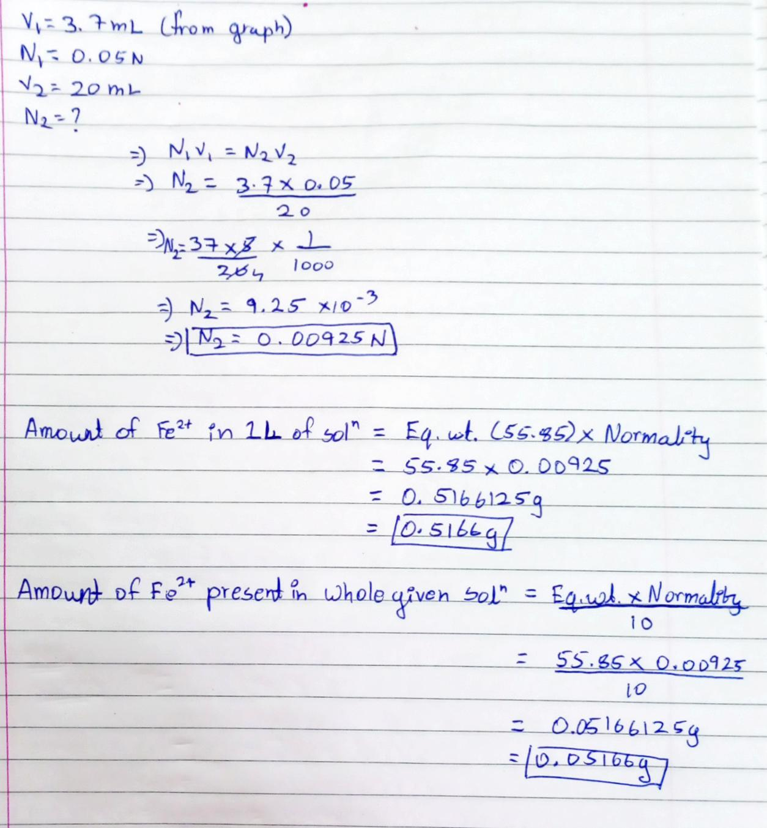

GRAPH:
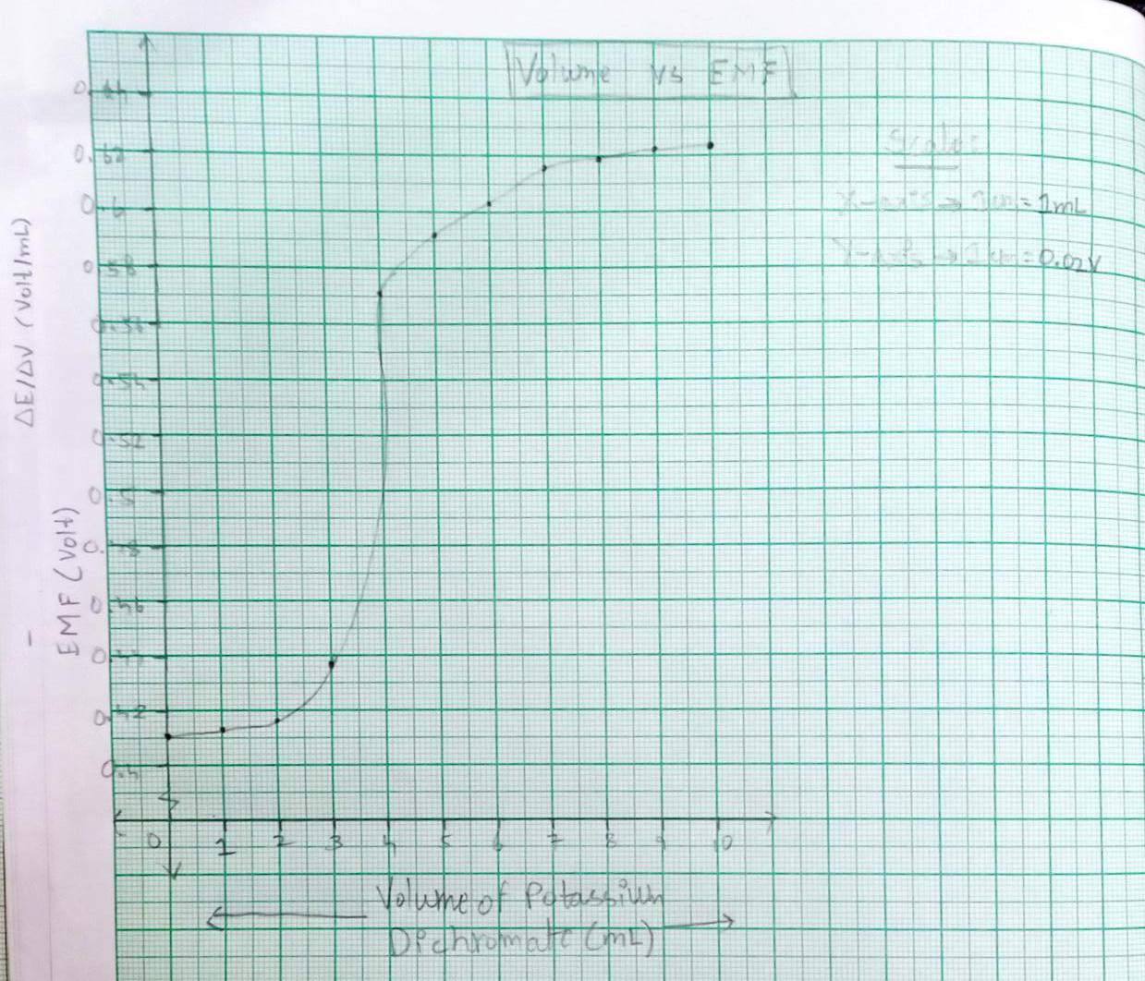

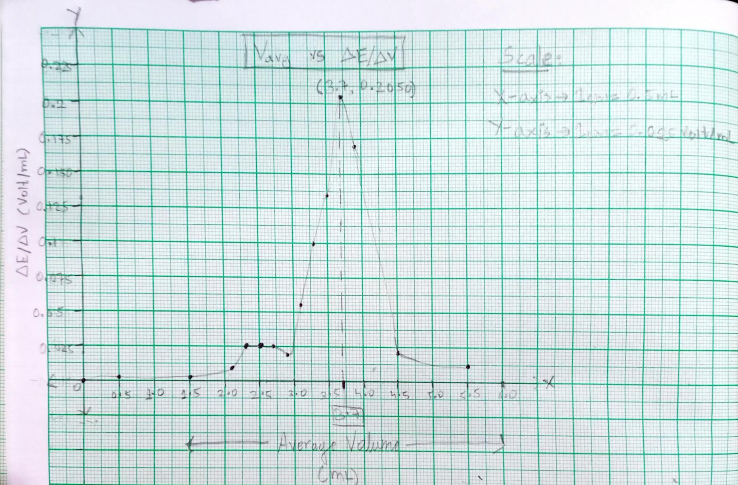

Result:
- Equivalence point determined from the graph = 3.7 ml
- The amount of Fe2+ ion present in one litre of the given solution = 0.5166g

